Spring Data JPA with Spring Boot, Hibernate Assignments
Spring Data JPA - Quick Example
Spring Initializer:
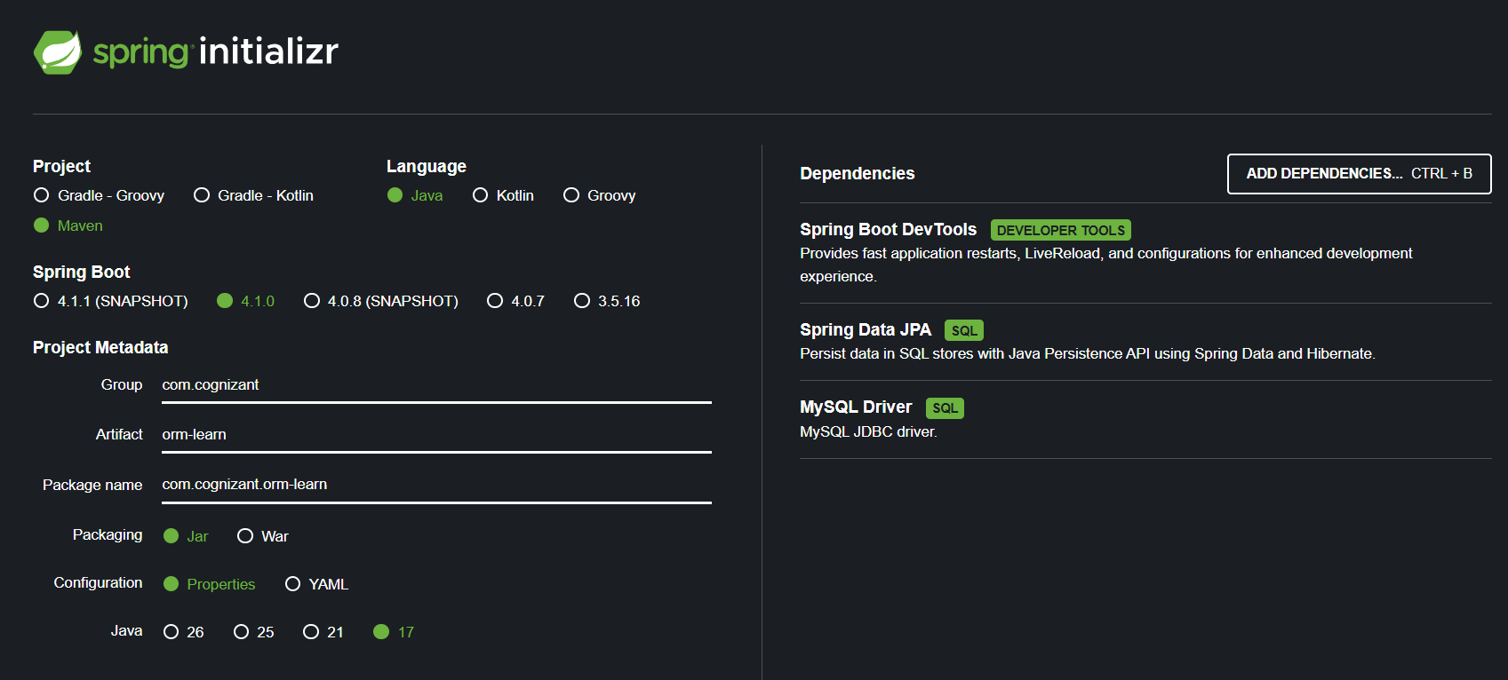
Creating Database:
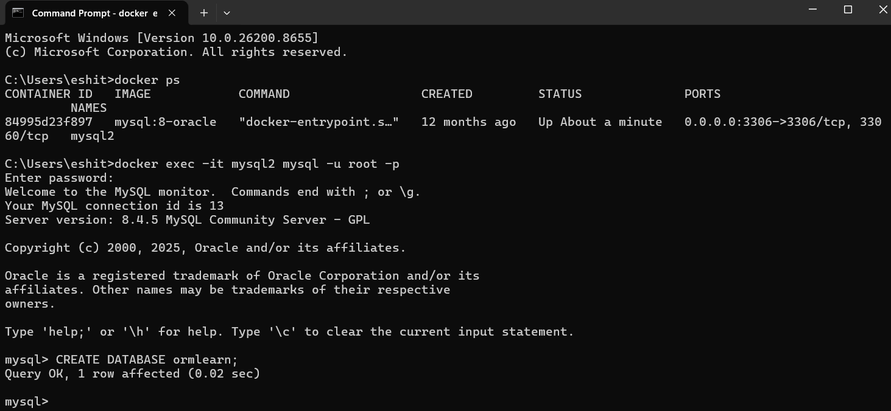
application.properties:
# Spring Framework and application log
logging.level.org.springframework=info
logging.level.com.cognizant=debug
# Hibernate logs for displaying executed SQL, input and output
logging.level.org.hibernate.SQL=trace
logging.level.org.hibernate.type.descriptor.sql=trace
# Log pattern
logging.pattern.console=%d{dd-MM-yy} %d{HH:mm:ss.SSS} %-20.20thread %5p %-25.25logger{25} %25M %4L %m%n
# Database configuration
spring.datasource.driver-class-name=com.mysql.cj.jdbc.Driver
spring.datasource.url=jdbc:mysql://localhost:3306/ormlearn
spring.datasource.username=root
spring.datasource.password=root
# Hibernate configuration
spring.jpa.hibernate.ddl-auto=validate
spring.jpa.properties.hibernate.dialect=org.hibernate.dialect.MySQL5Dialect
Maven Project Build
The project was built using the following Maven command from the project directory:
Successful build of the orm-learn project using Maven:
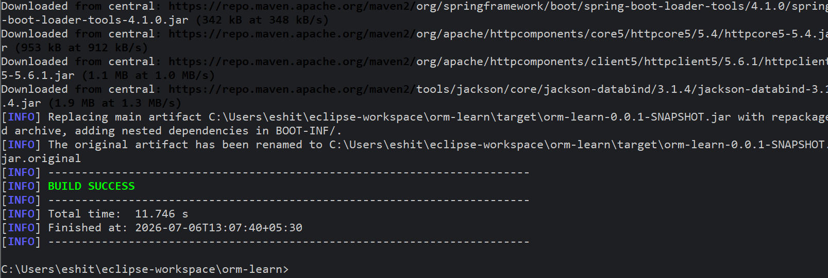

OrmLearnApplication.java
package com.cognizant.orm_learn;

import org.springframework.boot.SpringApplication;
import org.springframework.boot.autoconfigure.SpringBootApplication;
import org.slf4j.Logger;

import org.slf4j.LoggerFactory;

@SpringBootApplication
public class OrmLearnApplication {
private static final Logger LOGGER = LoggerFactory.getLogger(OrmLearnApplication.class);

public static void main(String[] args) {
SpringApplication.run(OrmLearnApplication.class, args);
LOGGER.info("Inside main");
}

}

OUTPUT:
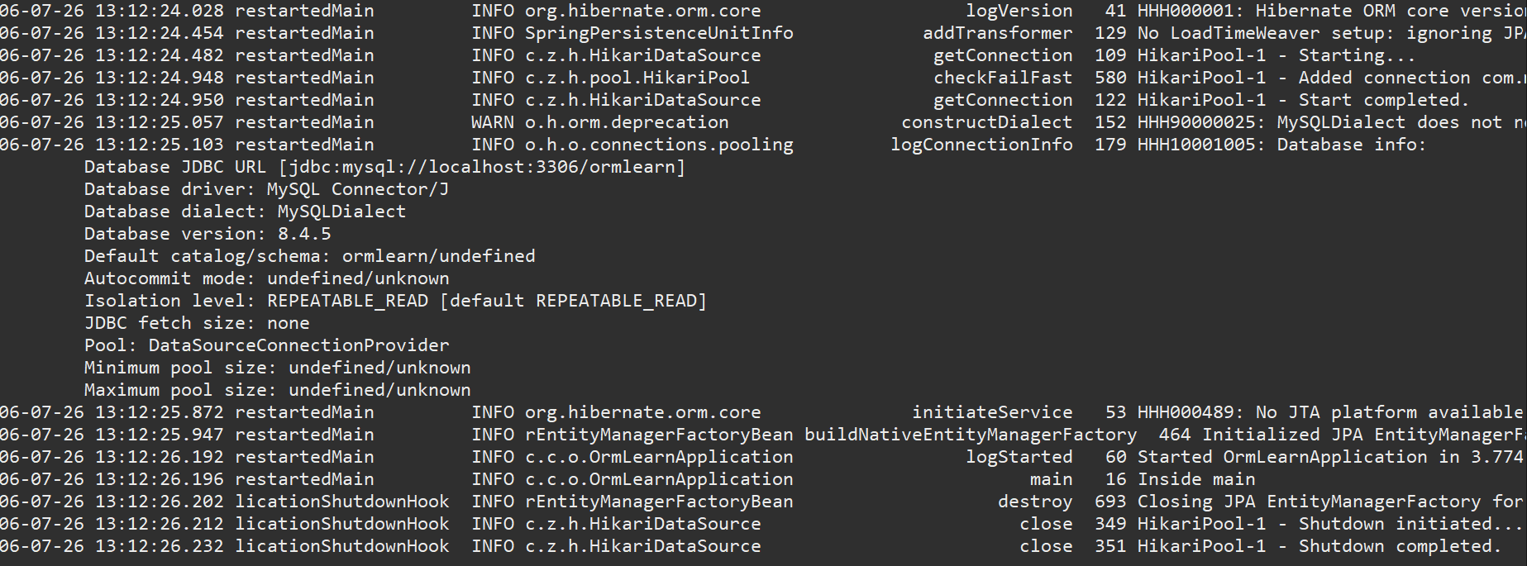
Project Structure:
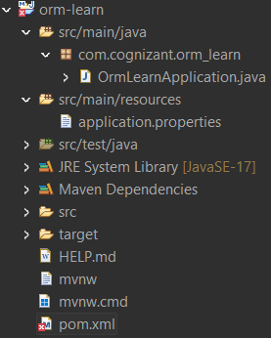
Country Table Creation:
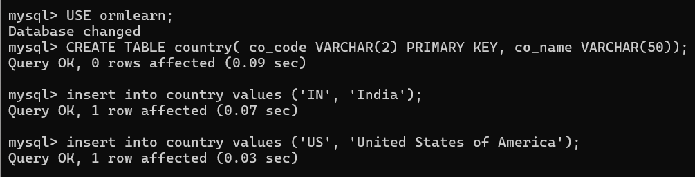
Country.java:
package com.cognizant.orm_learn.model;

import jakarta.persistence.Column;
import jakarta.persistence.Entity;
import jakarta.persistence.Id;
import jakarta.persistence.Table;

@Entity
@Table(name = "country")
public class Country {

@Id
@Column(name = "co_code")
private String code;

@Column(name = "co_name")
private String name;

public String getCode() {
return code;
}

public void setCode(String code) {
this.code = code;
}

public String getName() {
return name;
}

public void setName(String name) {
this.name = name;
}

@Override
public String toString() {
return "Country [code=" + code + ", name=" + name + "]";
}
}
CountryRepository.java
package com.cognizant.orm_learn.repository;

import org.springframework.data.jpa.repository.JpaRepository;
import org.springframework.stereotype.Repository;

import com.cognizant.orm_learn.model.Country;

@Repository
public interface CountryRepository extends JpaRepository<Country, String> {

}
CountryService.java
package com.cognizant.orm_learn.service;

import java.util.List;

import org.springframework.beans.factory.annotation.Autowired;
import org.springframework.stereotype.Service;
import org.springframework.transaction.annotation.Transactional;

import com.cognizant.orm_learn.model.Country;
import com.cognizant.orm_learn.repository.CountryRepository;

@Service
public class CountryService {

@Autowired
private CountryRepository countryRepository;

@Transactional
public List<Country> getAllCountries() {
return countryRepository.findAll();
}
}

Successful retrieval of country records from MySQL database using Spring Data JPA
